Kick-off on 6.6!
The 13th Fresh Wave International Short Film Festival
Download Images: https://bit.ly/2R16dM6

(Hong Kong, 10 June 2019) Presented by the Fresh Wave Film Festival Limited, the Opening Ceremony of 13th Fresh Wave International Short Film Festival was held last Thursday (6 June) at Kubrick (Yau Ma Tei). During the Festival period (from 6 to 22 June 2019), 55 local and overseas films to be screened at Broadway Cinematheque, MOViE MOViE Cityplaza and MY CINEMA YOHO MALL. Tickets are now available at broadway circuit. Intimate interviews with participating local directors, Asia budding filmmakers and Jury Panel for the final selection of Local Competition are welcome.

Kick-off by Directors ZHANG Ming & Johnnie TO + Aaron KWOK
Giving a speech at the Ceremony, Mr Lofai Lo, Director and General Manager of HK Television Entertainment Company Limited, shared the two roles of ViuTV. The first one is “conveyer”, showcasing the short films by budding filmmakers to audience through TV channel. Another role is “beneficiary“, as many past participants of Fresh Wave also work for ViuTV these years. He appreciated and expected more new blood could be cultivated by Fresh Wave.

Mr Johnnie To and Mr Aaron Kwok then shared their expectations on emerging local filmmakers. Mr Kwok thought that is remarkable for the 13 years of Fresh Wave. He also encouraged budding filmmakers to be passionate and persist on the works. Mr To also highlighted the key to be a filmmaker is creativeness. The film is belonging to director and the team. “Don’t copy from others, keep the originality of work.”

Another opening guests, Mr ZHANG Ming, director of The Pluto Moment , and Mr Eric TSANG, director of A Thousand Sails also shared their hand-on experience of filmmaking. “It is tough to make film in China,” stated Mr Zhang and he also mention Hong Kong movie is used to be their enlightened films. “I just keep persisting and working hard on what I wanted to do in these few years.” said Eric.

Other guests include Board of Directors of Fresh Wave Film Festival Limited - SHU Kei (Vice Chairman), NG Chun-hung, SHUM Long-tin, Winnie TSANG, Calvin WONG Chee-jun, Susan WONG; 19 participating directors & crew (Local Competition); Ms Winsome CHOW, Chief Executive of the Hong Kong Arts Development Council; Mr TONG Hing-chi, Managing Director of Mei Ah Entertainment; Mr Fruit Chan, Mr Ben Yuen, etc.

10 Themed Programmes To Observe the Nature of Humanities
Apart from the Opening Film and Short mentioned above, 19 local and 23 international short films are to be screened and make 10 themed programmes. Each programme, namely “Having as Losing”, “Love vs Duty”, “We are Family”, “A Comedy of Errors”, “Multiple Sex Choices”, “Who Invented Work?”, “Vain is Hope”, “Men and the City”, “The Marginal”, “Read and Done For”, consists of 4-5 local and international short films and accompanied by sharing sessions with the local directors. By appreciating and comparing the works of both local and international filmmakers, we reflect upon and rethink about our relationship with society and the world, so as to understand ourselves better and open up further possibilities.

8 Must-watch
The rich programme encompasses a wide array of themes such as the everyday, socio-political issues, romance, teenage angst etc. The works participating in Local Competition show not only the creativity of the filmmakers, but also their sensitivity to society. To foster exchange between local and international film cultures and broaden the vision of local film practitioners and audience, the Festival collaborates with overseas film festivals and organisations, namely The International Association of Film and Television Schools (CILECT), British Academy of Film and Television Arts (BAFTA), and Clermont-Ferrand International Short Film Festival, in screening outstanding short films from around the world, for example UK, USA, Germany, France, Switzerland, Poland, Ireland, Mexico, Israel, Bulgaria, etc. Many of them are award-winning titles. 8 must-watch include:

1/ Opening Film The Pluto Moment: Directed by Zhang Ming, one of the “6th generation” filmmakers from China, this film reflects his frustrations and hardships in filmmaking. Chloe Maayan (Three Husbands) shines with her role as an enigmatic young widow.
2/ Opening Film A Thousand Sails: The new short film by Eric Tsang, winner of last year’s Fresh Wave Award), is a short tale about the poignant separation between city and village, mother and son
3/ NEW! Budding Filmmakers: The new addition this year is the Budding Filmmakers to Follow Series, which showcases nine recommended short films directed by emerging Asian filmmakers, namely Chieh YANG, HOU Chi-jan, River HUANG and Takuma SATO. Including Cronos (Best Editing (Opening Division) Golden Harvest Awards), Scissors And The Cat, Girl And Boy, Sticks And Stones.
4/ NEW! Shorts from the Darkness: Two short films, Butterfly and Darkness In Light, selected from the Screenwriting Competition launched by Filmmaker in Focus Series: Stalker in the Dark – The Films of CHANG Tso-chi (2018).
5/ Dilemma: Spawning Migration, I Come Empty-handed & PT Human from Local Competition; Facing Mecca (winner of CILECT Prize 2018 - Fiction) & Trials (Grand Prix, VGIK International Student Festival) from International Selection
6/ Family’s Struggle: Seventeen Floor & The Redemption from Local Competition; Little Jaffna (Prix Canal +, Clermont-Ferrand International Short Film Festival) & By A Hair (Pile Poil) (Fernand Raynaud Laughter Award) from International Selection
7/ Boundaries of love?: The Dropout Of Her & Call Girl And The Pimps from Local Competition; At The Border (CIBA Best Film – Fiction, CILECT Prize 2018) & Pernicio (Best Student Film, Richard Harris International Film Festival) from International Selection
8/ Post-Credits Cookies: The 19 shorts from Local Competition are to be judged by prestigious panel. They include Dr Wafa GHERMANI, Dr Li Yang, Mr Pema TSEDEN and Ms Joyce YANG. Awards are presented for Best Cinematography, Best Screenplay, Best Director and Fresh Wave Award to the best short films. Results will be announced at the Closing and Awards Presentation Ceremony on 21 June, followed by screenings for the awards winning titles on 29-30 June 2019.

Special: Collaborative Works Screening
During the Festival, three young overseas directors awarded by the CILECT Prize 2018, including director of Provence Kato De Boeck, director of At the Border Tomás Zalaba & director of Abdullah’s Wonderland LIU Mingshan, will be participating in a collaborative project with three local directors, in which one overseas director will pair up with a local director to co-direct a piece of narrative work within 3 minutes in Hong Kong. The finished product will be screened together with the award winning titles of Local Competition.

Fresh Wave x ViuTV
As an extension of past year’s success, the Festival is collaborating with ViuTV again this year. Starting from 8 July 2019, a series of specular programmes and selected short films will be shown on ViuTV 99 to the public.

Interview Opportunities
Intimate interviews with opening guests, Jury Panel for the final selection of Local Competition, Asia budding fimmakers and participating local directors are welcome.

Interviewees |  | Suggested angles
Directors | Mr Eric TSANG  - Director of Opening Short A Thousand Sails  - Winner of Fresh Wave Award at the 12th Fresh Wave International Short Film Festival | - In-depth features on film  - Film appreciation  - Life as a Director  - Messages to young people in the film industry
Mr Pema TSEDEN (one of the Jurors of Local Competition)
- Director of Jinpa, Tharlo & The Silent Holy Stones One Fine Day from China
Jury Panel of Local Competition | Dr Wafa GHERMANI  - Veteran Film Festival curator in France | - An overview of the development of short films  - Comments on the professional standard and potentials Hong Kong young filmmakers  - Insights into the industry
Dr LI Yang
- Vice-dean of the School of Arts, Peking University
Dr Timmy CHEN
- Research Assistant Professor at the Academy of Film, Hong Kong Baptist University
Ms Joyce YANG
- Film critic
Directors from Budding Filmmakers to Follow Series | Takuma SATO  Date: 14 – 16 June  *please inform interview in advance for arrangement | - Stories about dreams come true  - Insider tips & practical skills
19 participating Fresh Wavers |  | - Stories about dreams come true  - Insider tips & practical skills
6 participants of the collaborative project |  | - Live recording during shooting  - Sharing from participants
*Attached please find the “Appendix Biographies”.

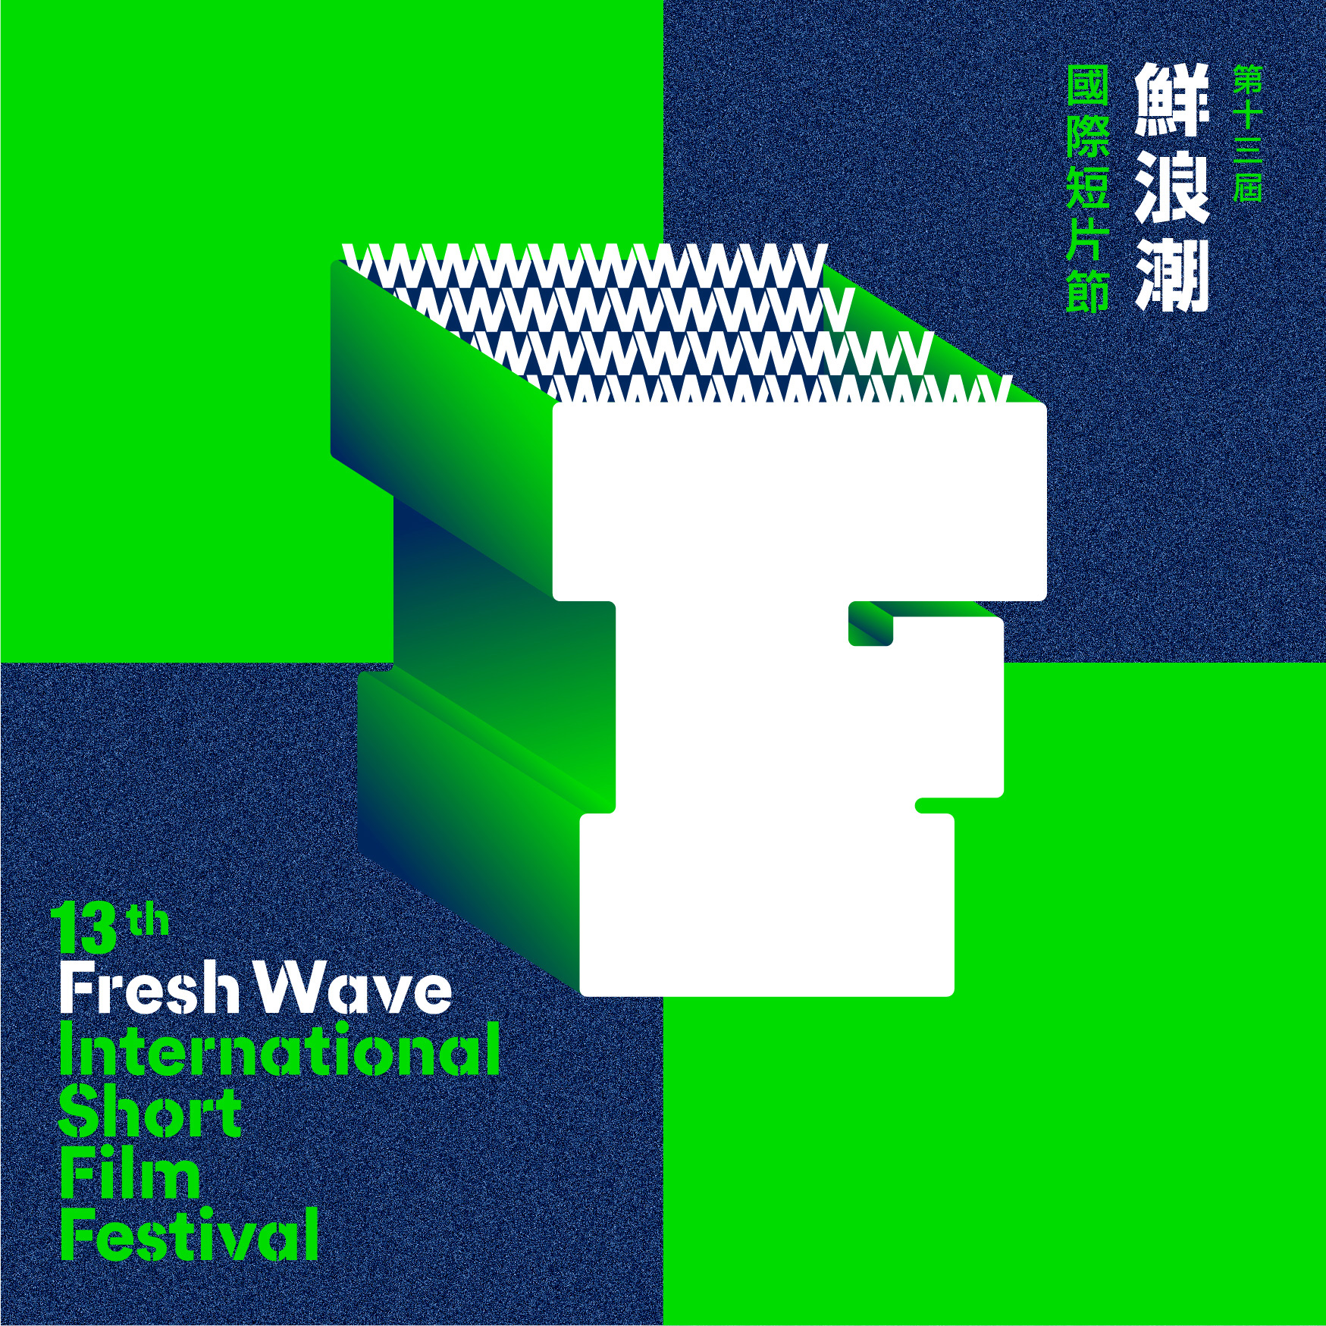 | The 13th Fresh Wave International Short Film Festival  Festival Period: 6 - 22 June 2019  Post-Credit Cookies: 29 - 30 June 2019  Tickets are NOW available on broadway circuit:  http://www.cinema.com.hk/en/movie/special/25  Details: www.freshwave.hk  Programme Guide: https://bit.ly/30mwglb  Download Images: https://bit.ly/2R16dM6

For complimentary tickets and one-on-one interviews, please contact Lun for assistance. (3619 4520 / 6312 4068 ; wong_wai_lun@freshwave.hk)

~End~

About Fresh Wave International Short Film Festival
Organised by Fresh Wave Film Festival Limited (Fresh Wave), the annual Fresh Wave International Short Film Festival takes place in March and April, with the aim to promote and encourage local short film production, and to discover and nurture young talents by providing funding support and a platform for showcasing their work, while enhancing their technical skills and quality through training. Led by founder and chairman Mr Johnnie TO, Fresh Wave proactively develops resources and channels to assist emerging filmmakers, striving towards a more dynamic local film industry. At the same time, Fresh Wave continues to explore into the areas of film criticism, education and cultural exchange, building a conducive environment for filmmaking and appreciation through retrospectives, school screenings and talk events. “The 12th Fresh Wave International Short Film Festival” comprises of “Local Competition” and “International Selection.”

Local Competition
The competition is open to aspiring filmmakers aged between 18 and 35. After the selection by a panel of professional jurors, selected candidates would each receive a subsidy of one hundred thousand Hong Kong Dollars for the production of a short film of 10 to 30 minutes long, to be screened at the Festival. Awards are presented for Best Cinematography , Best Screenplay, Best Director and Fresh Wave Award to the best short films.

International Selection
To foster exchange between local and international film cultures and broaden the vision of local film practitioners and audience, the Festival collaborates with overseas film festivals and organisations, including The International Association of Film and Television Schools (CILECT), British Academy of Film and Television Arts (BAFTA) and Clermont-Ferrand International Short Film Festival, in screening outstanding short films from around the world.

Media & Programme Enquiry
Wong Wai Lun (Communications Officer)  Tel: 3619 4520 / 6312 4068  Email: info@freshwave.hk | Simon Au (Senior Festival Officer)  Tel: 3619 4565

